Child Care Centre Accident/Injury Report
Name of Child Care Centre: Click here to enter text.

Accident Information
Child’s Full Legal Name: _________________________________________________
Date of Accident (dd/mm/yyyy) ______________
Time of Accident (hh:mm AM/PM): ___________
Location where the accident occurred (e.g., preschool room, playground etc.): _________________________________________
Name(s) of individual(s) who observed the accident: ______________________________________________________________________
Please circle the area(s) of the child’s body where the injury occurred: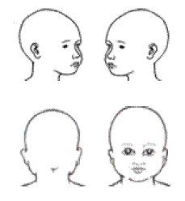 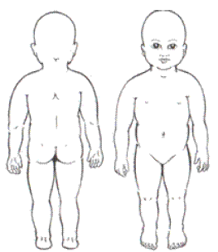

Nature of the Injury:
☐Bruise ☐Cut ☐Scrape ☐Bump
☐Other: ______________________________________________________________

Description of what Caused the Accident/Injury:
______________________________________________________________________
______________________________________________________________________
______________________________________________________________________
______________________________________________________________________
______________________________________________________________________

Child’s Reaction to the Accident/Injury:
☐Crying ☐Child has a positive attitude ☐No reaction from child
☐Other: ____________________

First Aid Administered and by Whom: _____________________________________________________________________
_____________________________________________________________________
_____________________________________________________________________

How and when the parent was notified:
☐ Phone Time notified: _________ By Whom: ____________
☐ Voicemail was left Time notified: _________ By Whom: ____________
☐ Email Time notified: _________ By Whom: ____________
☐ In-person at pick-up Time notified: _________ By Whom: ____________

Administrative Information
☐ A copy (via email or photocopy) of this report has been provided to a parent of the child by _________________ (name).
Note: ‘Parent’ is defined as a person having lawful custody of a child or person who has demonstrated a settled intention to treat a child as a child of his or her family, and includes legal guardians.
Parent Name (optional) ______________________
Parent Signature (optional): __________________ Date:___________________
Supervisor/Designate Signature:______________ Date:___________________
Note to Parents: Please consider providing us with a status update the next day that your child participates in the child care program, so that any additional health or safety needs can be met.
Name and position of the individual completing this form: ☐ same as above (supervisor/designate), or _________________________________________
Signature (if other individual completing this form): ________________________________

Regulatory Requirements: Ontario Regulation 137/15

Child illness and accident
36(4) Every licensee shall ensure that when a child receiving child care at a child care centre it operates or at a premises where it oversees the provision of home child care is injured,
(a) an accident report is made describing the circumstances of the injury and any first aid administered; and
(b) a copy of the report is provided to a parent of the child.
Disclaimer: This document is a sample template that has been prepared to assist licensees in understanding their obligations under the CCEYA and O. Reg. 137/15. It is the responsibility of the licensee to ensure that the information included in this document is appropriately modified to reflect the individual circumstances and needs of each child care centre it operates.
Please be advised that this document does not constitute legal advice and should not be relied on as such. The information provided in this document does not impact the Ministry’s authority to enforce the CCEYA and its regulations. Ministry staff will continue to enforce such legislation based on the facts as they may find them at the time of any inspection or investigation.
It is the responsibility of the licensee to ensure compliance with all applicable legislation. If the licensee requires assistance with respect to the interpretation of the legislation and its application, the licensee may wish to consult legal counsel.

